# Media Analysis - AI is not smarter than humans

## Short Summary

The article examines both ChatGPT's beneficial aspects in enhancing productivity and communication, while addressing concerns over its reliability, emotional understanding, and cultural sensitivity it also highlights AI's potential to transform marketing but reiterates the significance of human interaction.

## Summary

1. AI tools like ChatGPT are highly beneficial, offering personal assistance and enhancing business tasks through various applications.  
2. These AI systems can emulate real-life professionals such as recruiters, marketers, or CEOs, acting as intelligent digital assistants.  
3. Apple's Siri was a pioneering AI tool that significantly improved daily routines and communication with technology.  
4. Initial concerns about AI accuracy stem from the user's inherent limitations in grammar and language skills, which AI tools initially capitalized on but overcame through continuous learning and improvement.  
5. AI has shown great potential in business operations and marketing, providing valuable insights and ideas for campaigns. However, it may lack understanding of cultural nuances like feeling sentimental during national anthems.  
6. Despite advancements, AI cannot replicate the essential human connection. It assists humans but does not replace them in creating personalized messaging or tailored marketing content that carries emotional depth and meaning.  
7. As we continue to develop AI technology, it is crucial to ensure its reliability, maintain a balance between automation and human involvement, and preserve the unique value of human interaction in our increasingly interconnected world.

## Question 1:

How do the media in this article frame the public discussion about ChatGPT? Are there certain **metaphors** that keep cropping up?

The media in this article frames the public discussion about ChatGPT as a transformative force that can revolutionize various aspects of life through metaphors of evolution. The AI is depicted as rapidly evolving, much like how technology has progressed with the introduction of Siri and other virtual assistants.

## Question 2:

Which role does or might the Arabic World play in the development of Artificial Intelligence? Answer with 'Not mentioned' if not applicable.

Not mentioned

## Question 3:

Which use cases of Artificial Intelligence are helpful for the Arabic world based on this article?

The use cases of Artificial Intelligence that are helpful for the Arabic world, according to this article, include personal assistance via virtual assistants capable of handling diverse tasks, language translation tools like Google Translate to bridge linguistic gaps, and AI's potential in revolutionizing business operations and marketing strategies globally.

## Question 4:

What is the final message of the article that the author wants to convey? Keep your answer short and precise!

AI has immense potential to revolutionize various aspects of life, but it cannot replace the personal connection and nuanced understanding that humans provide.

## Sentiment

The sentiment is 2

## Entities

Ali Al Mustafa, Saint Mary University, Grace Business Operation Marketing Department Include Computer Understand Like Culture, Kid Singe, Ai Smart, Real Life Recruiter Marketer, National Anthem Look Ag

## Topic Clusters

### Cluster: Artificial Intelligence and Ethics

ChatGPT, AI societal effects

### Cluster: AI and Journalism

Arabic media coverage on ChatGPT, ChatGPT's impact on news reporting

### Cluster: AI in Education

AI-powered learning tools, ChatGPT for educational purposes

### Cluster: AI Bias and Fairness

Discussions on AI fairness in Arabic context, ChatGPT's potential biases

## Word Clouds

### Wordcloud of content

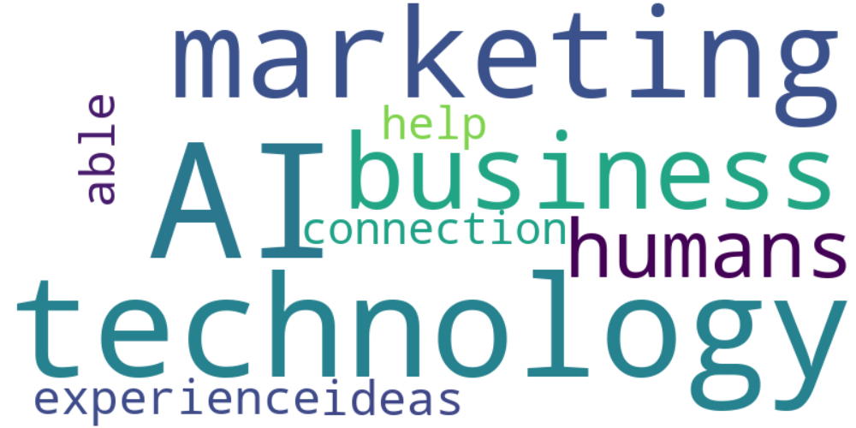

Top 10 words:

- AI: 10

- technology: 8

- marketing: 6

- like: 5

- business: 4

- humans: 3

- experience: 3

- able: 3

- ideas: 3

- connection: 3

### Wordcloud of summary

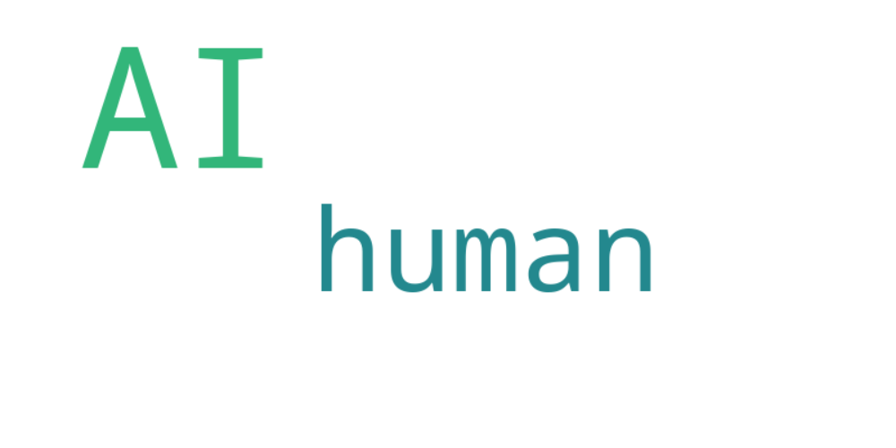

Top 10 words:

- AI: 8

- human: 3